FLOWCHART FOR PIZZA

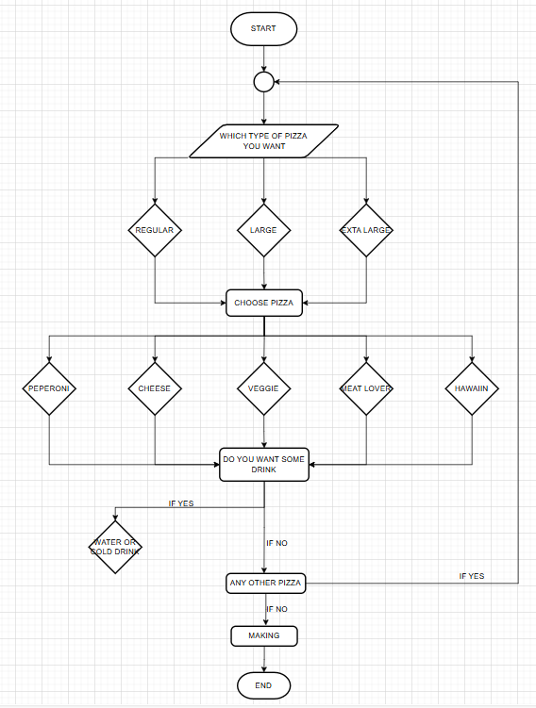

Pseudocode for Pizza

* Type of pizza
* Regular/large/extra-large
* Choose pizza type
* Pepperoni/veggie/meatlover/cheese/Hawaiian
* Any drink
* If yes which drink water or cod drink else go the any other pizza
* Any other pizza?
* If yes go the choose pizza else go to the making